ES - Sprint 2 – Design Pattern (GOF) 3

**Decorator**

Allows additional behaviours or responsibilities to be dynamically attached to an object, using aggregation/composition to combine behaviours at run time. This design pattern makes use of interfaces and inheritance, so that the classes conform to a common type whose instances can be stacked in a compatible way. This builds a coherent combination of behaviour overall.

* 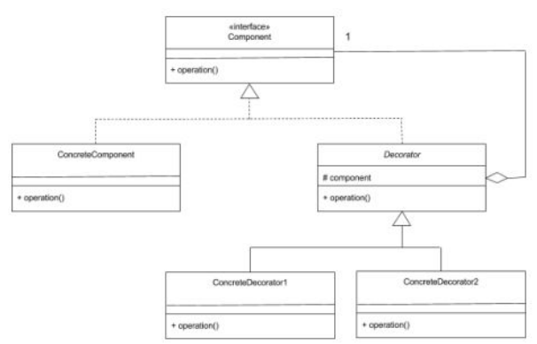**Structure**
* **Decorator java example (Code Snippet)**

1. Component Interface

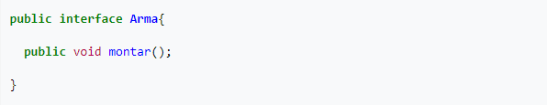

1. Concrete Component

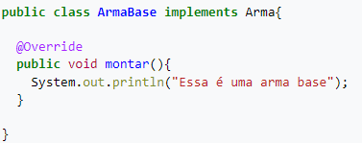

1. Decorator

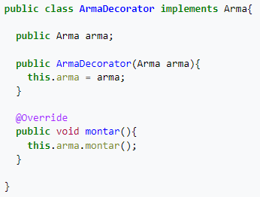

1. Concrete Decorator 1

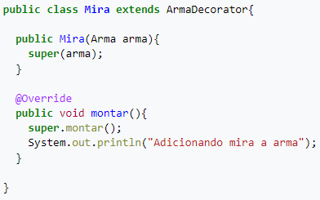

1. Concrete Decorator 2

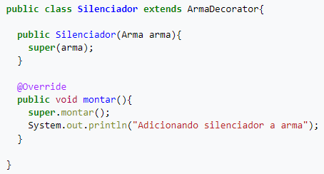

**Code location:**

* **Component Interface**

“*src\main\java\org\jabref\model\search\SearchMatcher.java*”

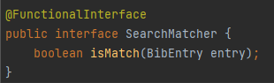

* **Concrete Decorator**

“*src\main\java\org\jabref\model\search\matchers\NotMatcher.java*”

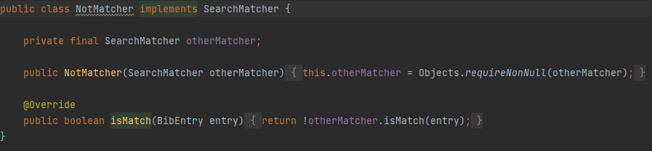

* **Decorator**

“*src\main\java\org\jabref\model\search\matchers\MatcherSet.java*”

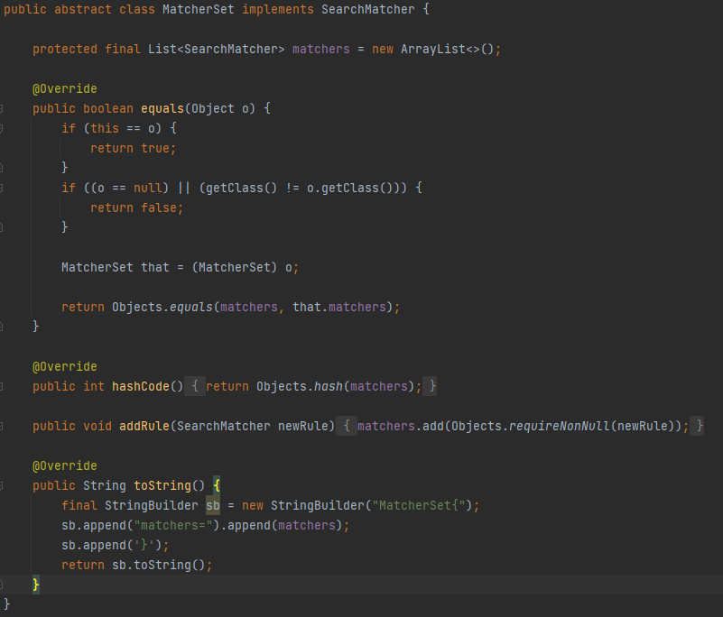

(matchers is the protected variable that stores a collection of type SearchMatcher (Component Interface) and the method isMatch (BibEntry entry) is implemented on the concrete decorator classes)

* **Concrete Decorator 1**

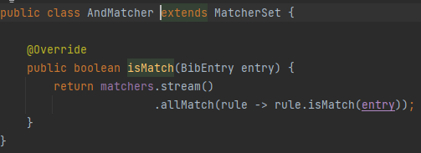“*src\main\java\org\jabref\model\search\matchers\AndMatcher.java*”

* **Concrete Decorator 2**

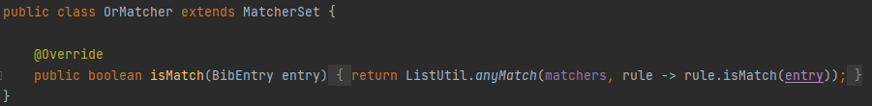“*src\main\java\org\jabref\model\search\matchers\OrMatcher.java”*

**Justification:**

Like we saw above exist a protected variable, which type is the interface. The class Decorator is abstract, and all the classes that extends this one (Concrete Decorators) implement the method isMatcher (BibEntry entry).